LABSHEET-5
SUNNY
CU240251760
ROLL NO- 58
SEC-B
- Download and install Tableau Public or Microsoft Power BI Desktop.
import
pandas
as
pd
import
matplotlib.pyplot
as
plt
- Import a real-world dataset such as the Superstore Sales Dataset, Global Superstore Dataset, or Amazon Sales Dataset.
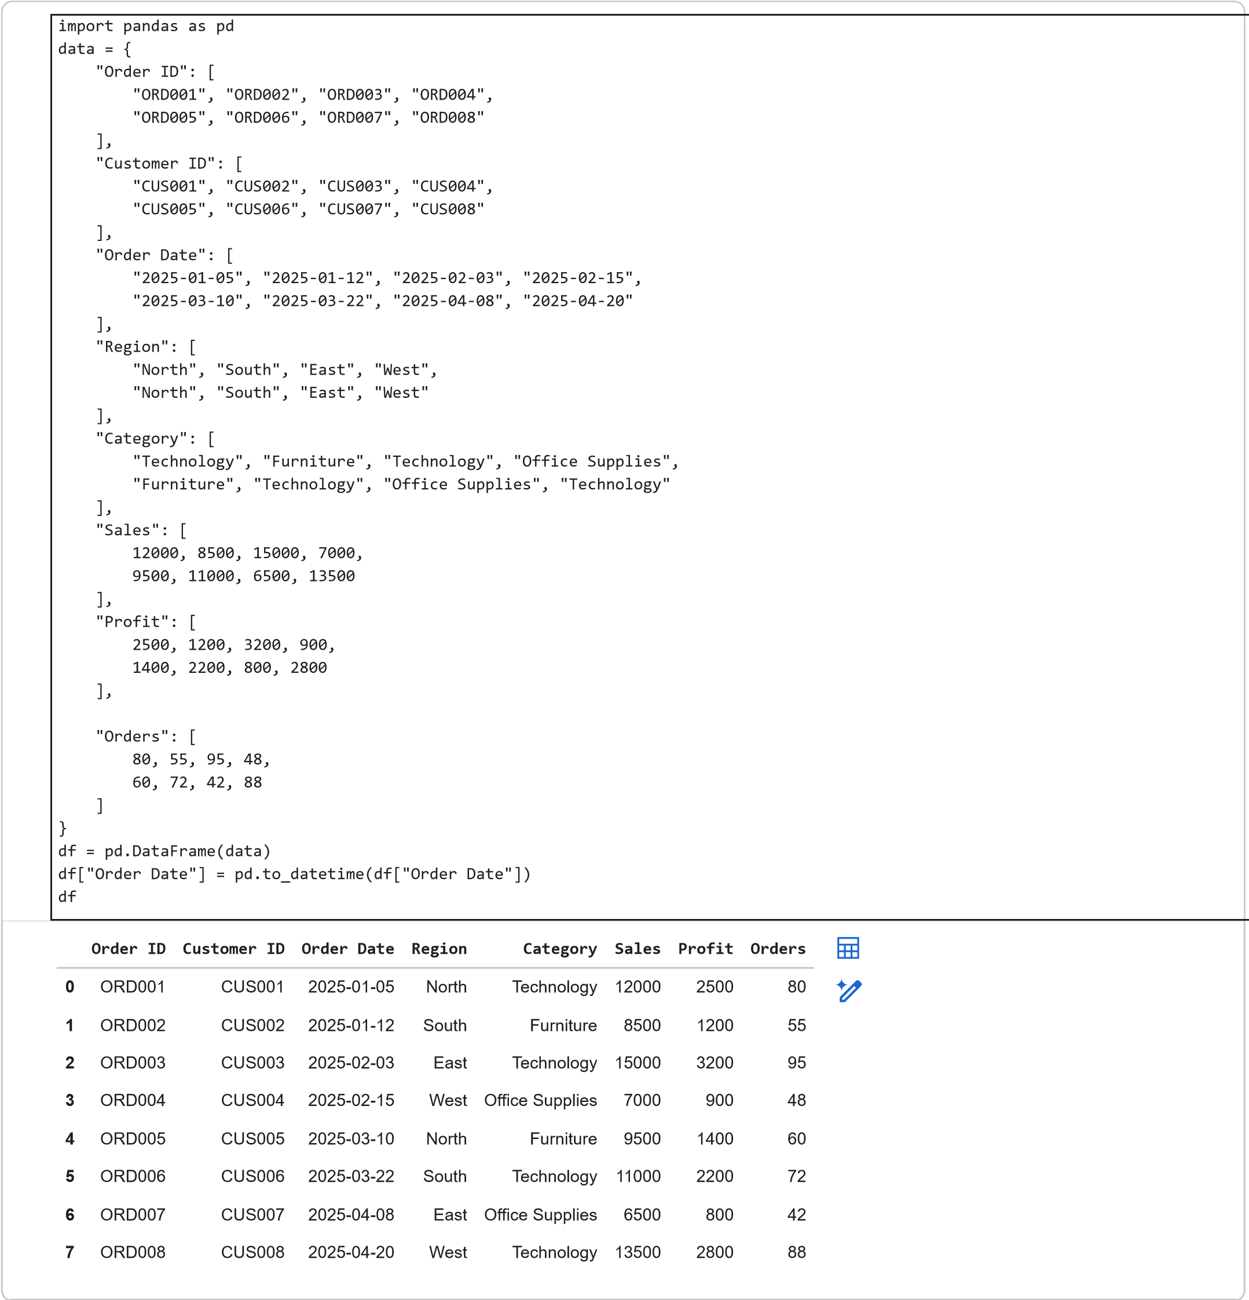
Next steps:
Generate code with
df
New interactive sheet
- Verify the imported data by checking field names, data types, and relationships between tables (if applicable).
print
(
"Dataset Shape:"
, df.shape)
print
(
"\nColumn Names:"
)
print
(
df.columns
)
print
(
"\nData Types:"
)
print
(
df.dtypes
)
print
(
"\nMissing Values:"
)
print
(
df.isnull
().
sum
())
Dataset Shape: (8, 8)
Column Names:
Index(['Order ID', 'Customer ID', 'Order Date', 'Region', 'Category', 'Sales',
'Profit', 'Orders'],
dtype='object')
Data Types:
Order ID object
Customer ID object
Order Date datetime64[ns]
Region object
Category object
Sales int64
Profit int64
Orders int64
dtype: object
Missing Values:
Order ID 0
Customer ID 0
Order Date 0
Region 0
Category 0
Sales 0
Profit 0
Orders 0
dtype: int64
- Create Key Performance Indicators (KPIs) such as Total Sales, Total Profit, Number of Orders, Average Order Value, orCustomer Count.
total_sales = df[
"Sales"
].
sum
()
total_profit = df[
"Profit"
].
sum
()
total_orders = df[
"Order ID"
]
.nunique
()
customer_count = df[
"Customer ID"
]
.nunique
()
average_order_value = total_sales / total_orders
print
(
"Total Sales:"
, total_sales)
print
(
"Total Profit:"
, total_profit)
print
(
"Number of Orders:"
, total_orders)
print
(
"Customer Count:"
, customer_count)
print
(
"Average Order Value:"
, average_order_value)
Total Sales: 83000
Total Profit: 15000
Number of Orders: 8
Customer Count: 8
Average Order Value: 10375.0
- Develop multiple visualizations, such as bar charts, line charts, pie charts, maps, and treemaps, to analyze businessperformance from different perspectives.
Sales by Category
category_sales = df.groupby(
"Category"
)[
"Sales"
].
sum
()
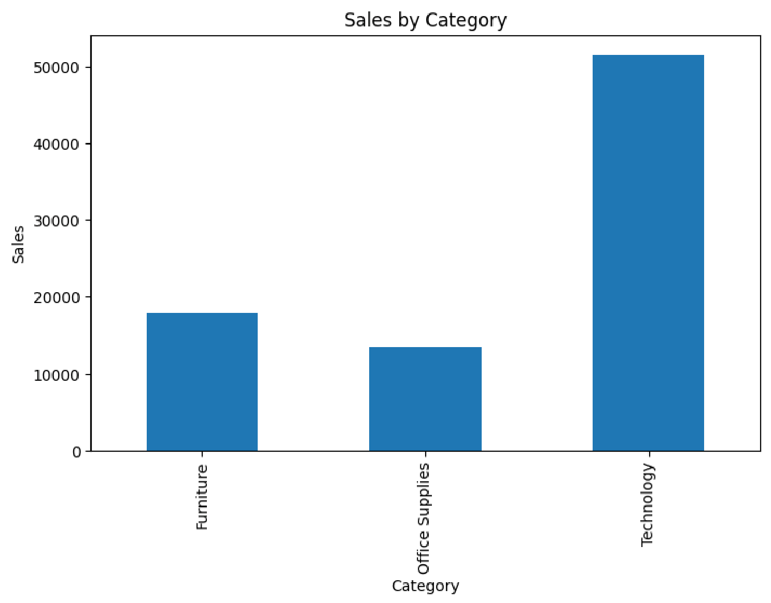
category_sales.plot(kind=
"bar"
, figsize=(
8
,
5
))
plt.title(
"Sales by Category"
)
plt.xlabel(
"Category"
)
plt.ylabel(
"Sales"
)
plt.show()
Sales by Region
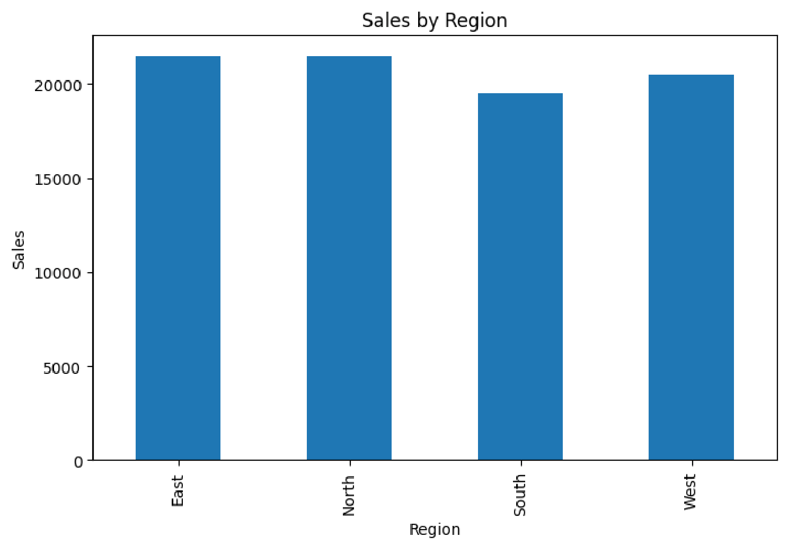
region_sales = df.groupby(
"Region"
)[
"Sales"
].
sum
()
region_sales.plot(kind=
"bar"
, figsize=(
8
,
5
))
plt.title(
"Sales by Region"
)
plt.xlabel(
"Region"
)
plt.ylabel(
"Sales"
)
plt.show()
Sales Trend
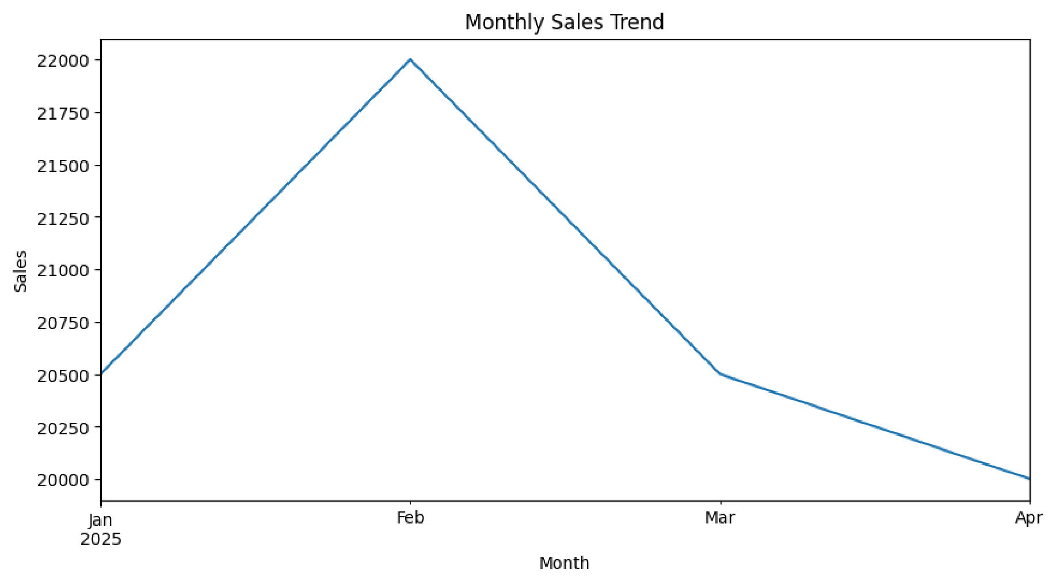
df[
"Order Date"
]
= pd.to_datetime(df
[
"Order Date"
])
monthly_sales = df.groupby(
df[
"Order Date"
]
.dt.to_period
(
"M"
)
)[
"Sales"
].
sum
()
monthly_sales.plot(figsize=(
10
,
5
))
plt.title(
"Monthly Sales Trend"
)
plt.xlabel(
"Month"
)
plt.ylabel(
"Sales"
)
plt.show()
- Add interactive filters, slicers, and drill-down features to allow users to explore the data by region, product category,customer segment, or time period.
Order ID
Customer ID
Order Date
Region
Category
Sales
Profit
Orders
0
ORD001
CUS001
2025-01-05
North
Technology
12000
2500
80
2
ORD003
CUS003
2025-02-03
East
Technology
15000
3200
95
5
ORD006
CUS006
2025-03-22
South
Technology
11000
2200
72
7
ORD008
CUS008
2025-04-20
West
Technology
13500
2800
88
technology = df[df[
"Category"
==
]
"Technology"
]
display(technology.head())
Filter by region:
Order ID
Customer ID
Order Date
Region
Category
Sales
Profit
Orders
3
ORD004
CUS004
2025-02-15
West
Office Supplies
7000
900
48
7
ORD008
CUS008
2025-04-20
West
Technology
13500
2800
88
west_region = df[df[
"Region"
]
==
"West"
]
display(west_region.head())
- Arrange all visualizations into a professional dashboard with appropriate titles, formatting, and layout.
print
(
"========== SALES DASHBOARD =========="
)
print
(
"Total Sales:"
,
round
(
total_sales,
2
)
)
print
(
"Total Profit:"
,
round
(
total_profit,
2
)
)
print
(
"Total Orders:"
, total_orders
)
print
(
"Customer Count:"
, customer_count
)
print
(
"Average Order Value:"
,
round
(
average_order_value,
2
)
)
==========
SALES DASHBOARD
==========
Total Sales: 83000
Total Profit: 15000
Total Orders: 8
Customer Count: 8
Average Order Value: 10375.0
- Analyze the dashboard to identify business trends, top-performing products, high revenue regions, and areas requiringimprovement.
top_category = category_sales.idxmax
(
)
top_region = region_sales.idxmax
(
)
print
(
"Top Performing Category:"
, top_category
)
print
(
"Top Performing Region:"
, top_region
)
Top Performing Category: Technology
Top Performing Region: East
- Publish or export the dashboard for presentation and sharing with stakeholders.
print
(
"========== KEY BUSINESS INSIGHTS =========="
)
print
(
"1. The highest-selling category is:"
, top_category
)
print
(
"2. The highest-revenue region is:"
, top_region
)
print
(
"3. Total sales are:"
,
round
(
total_sales,
2
)
)
print
(
"4. Total profit is:"
,
round
(
total_profit,
2
)
)
print
(
"5. Total number of orders is:"
, total_orders
)
==========
KEY BUSINESS INSIGHTS
==========
1
. The highest-selling category is: Technology
2
. The highest-revenue region is: East
3
. Total sales are
: 83000
4
. Total profit is
: 15000
5
. Total number of orders is:
8
- RESULT:
An interactive business dashboard was developed using the sales dataset. KPIs, charts, filters and business insights were generated to analyze sales performance and support data-driven decision-making.
